DEFENDED!

Table of Contents

## A dissertation is an extraordinary amount of work. Congratulations to each of these individuals who defended.

Since 2015, all SPU dissertations from Clinical and Industrial/Organizational Psychology are available in [full-text](https://digitalcommons.spu.edu/etd/) in our institution’s Digital Commons.

**Justin Cospito, M.A.**, [*When the Gay Can’t be Prayed Away: Exploring the LGBTQ Climate of a Non-Affirming Free Methodist University within the Council for Christian Colleges and Universities.*](https://digitalcommons.spu.edu/iop_etd/38/), 2022. Dissertation committee members included Joey Collins, PsyD (Chair), Lynette Bikos, PhD, ABPP (Co-Chair), and Matthew Bellinger, PhD.

Justin is completing his coursework in the Industrial-Organizational Psychology PhD program and pursuing a career in user experience research. You can find him on [LinkedIn](https://www.linkedin.com/in/cospitoj/)

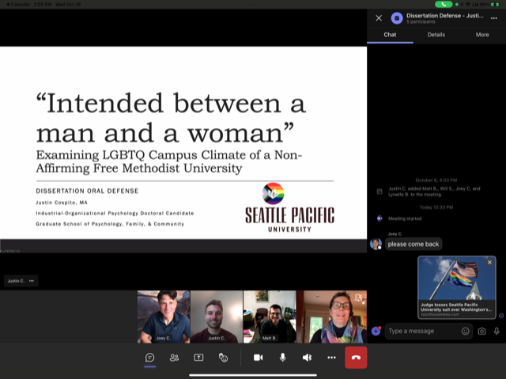

*Image of Justin’s dissertation defense*.

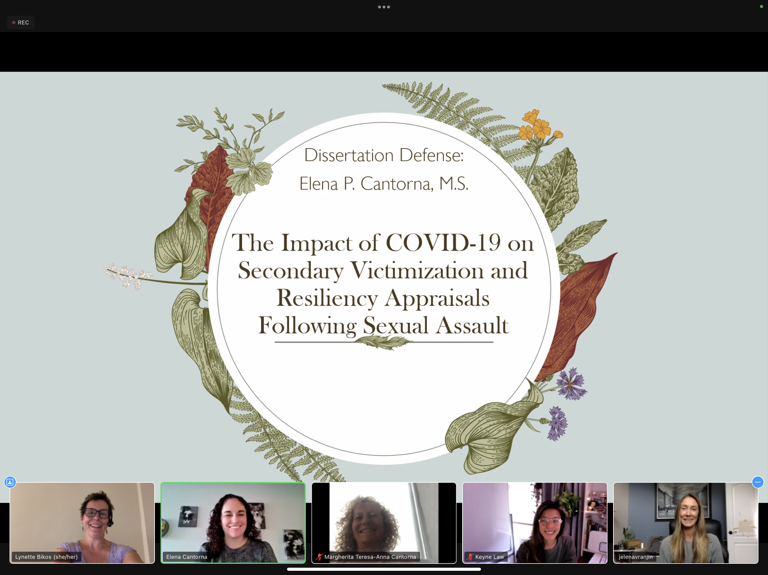

*Image of Elena’s virtual dissertation defense*.

**Elena Cantorna, M. S.**, [*The Impact of COVID-19 on Secondary Victimization and Resiliency Appraisals Following Sexual Assault*](https://digitalcommons.spu.edu/cpy_etd/84/), 2022. Dissertation committee members included Lynette Bikos, PhD, ABPP (Chair), Keyne Law, PhD, and Jelena Vranjin, PhD.

Elena is completing an APA-accredited pre-doctoral internship at the Center for Behavioral Medicine in Kansas City, MO. You can find her on [LinkedIn](https://www.linkedin.com/in/elenacantorna/)

**LeAnne Zaire, M.S.**, [*Behavioral and Disciplinary Outcomes of Black Students Who Have Black Teachers.*](https://digitalcommons.spu.edu/cpy_etd/82/), 2022. Dissertation committee members included Lynette Bikos, PhD, ABPP (Chair), Jake Bentley, PhD, ABPP, and Jordan Shannon, PhD.

LeAnne is completing an APA-accredited pre-doctoral internship at the El Paso Psychology Internship Consortium, El Paso, TX. You can find her on [LinkedIn](https://www.linkedin.com/in/leanne-zaire/)

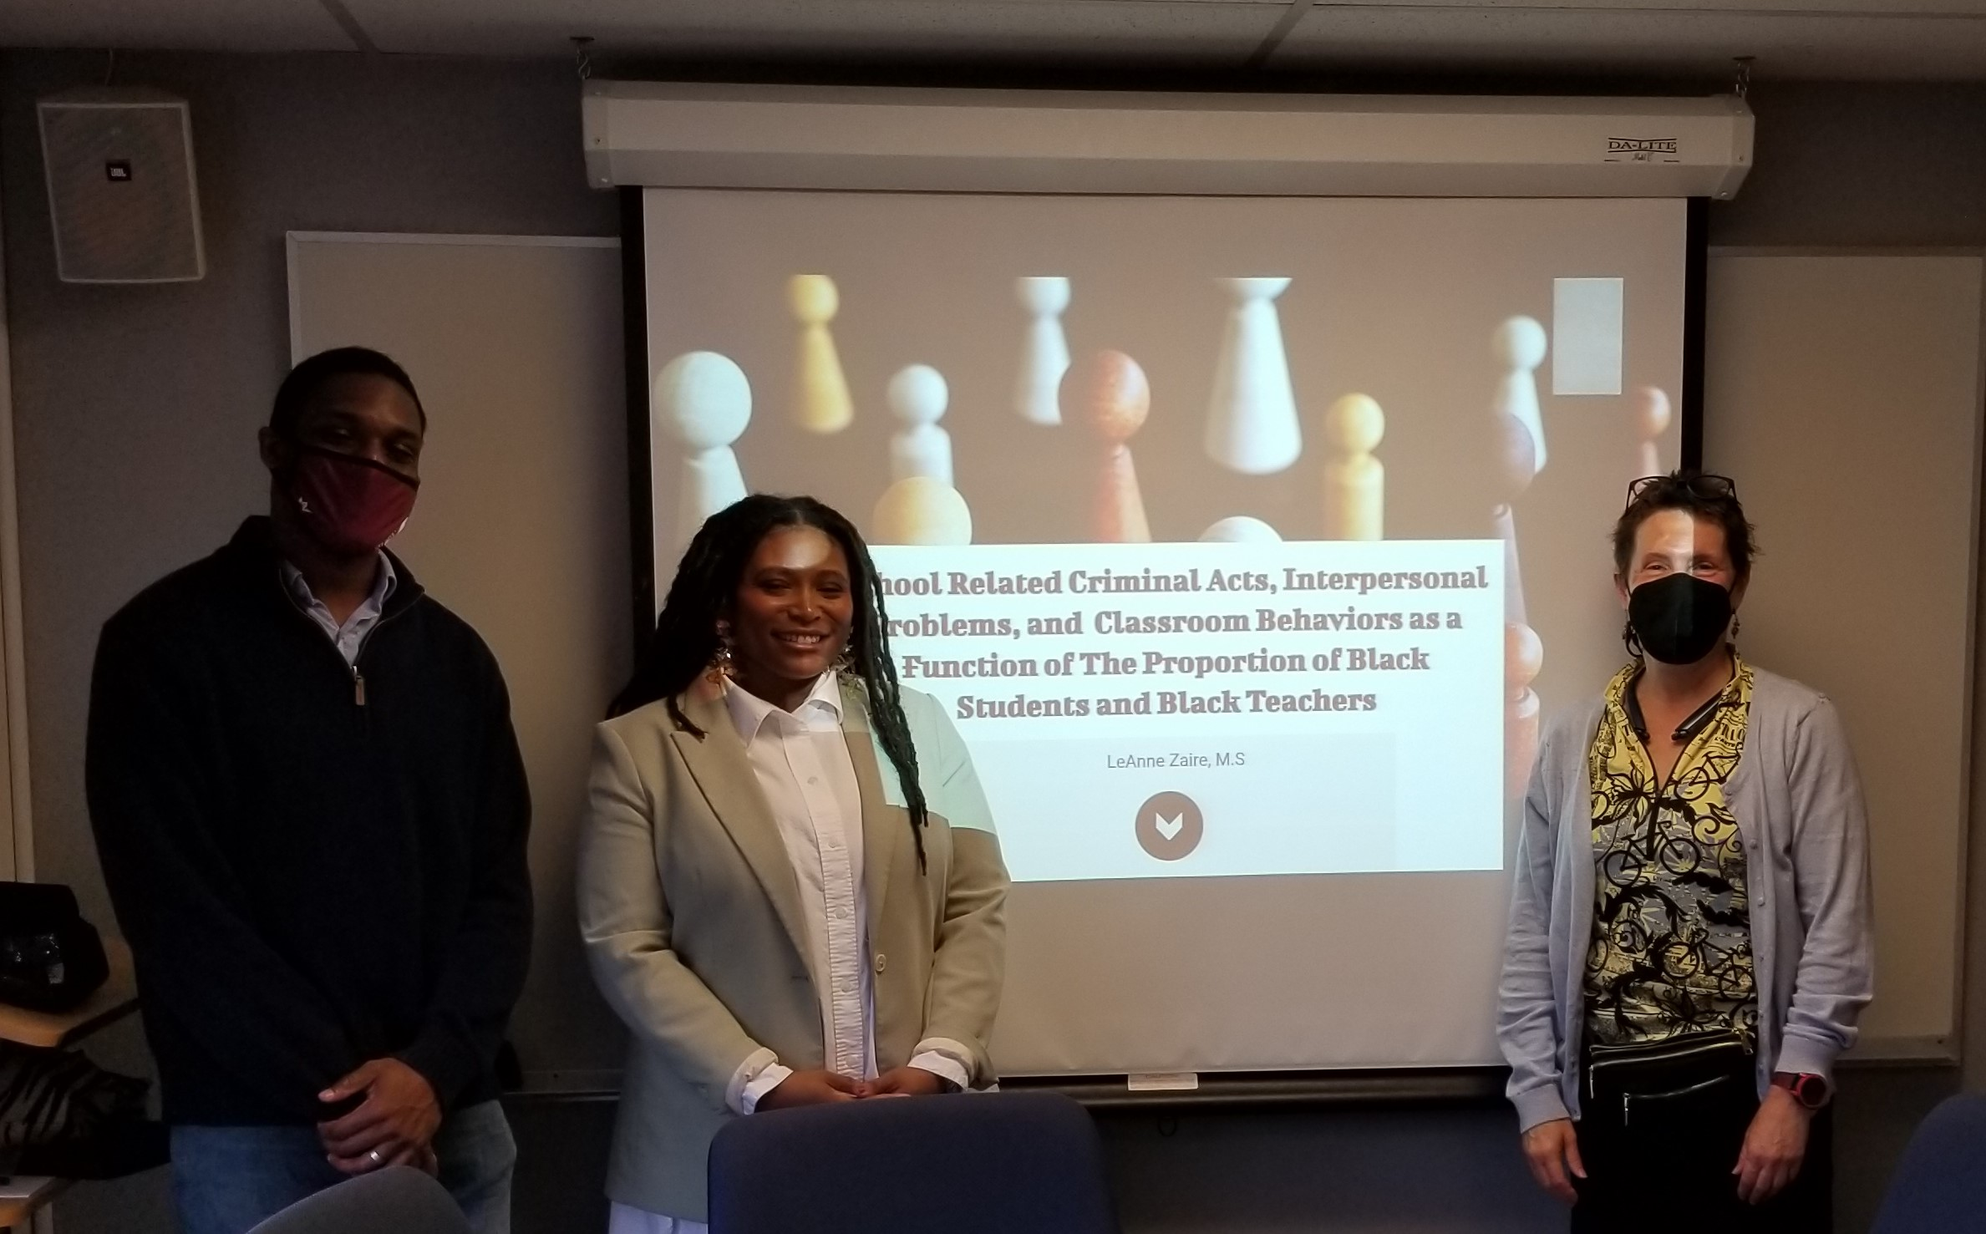

*Image of LeAnne’s dissertation defense*.

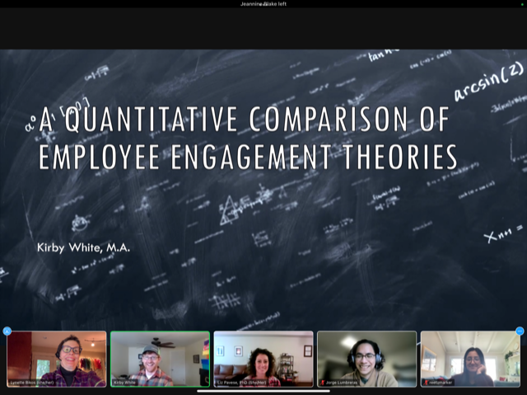

*Image of Kirby’s virtual dissertation defense*.

**Kirby White, PhD**, [*A Quantitative Comparison of Employee Engagement Theories*](https://digitalcommons.spu.edu/iop_etd/37/), 2022. Dissertation committee members included Lynette Bikos, PhD, ABPP (Chair), Jorge Lumbreras, PhD, and Liz Pavese, PhD.

Dr. White is building a career at the intersection of innovation consulting and climate tech. You can find him on [LinkedIn](https://www.linkedin.com/in/kirbywhite/)

**Lauren Hirsch, PhD**, [*The Role of Coping Self-Efficacy, Coping Strategies, and Resiliency Following Sexual Assault*](https://digitalcommons.spu.edu/cpy_etd/77/), 2022. Dissertation committee members included Lynette Bikos, PhD, ABPP (Chair), Jake Bentley, PhD, ABPP, and Jelena Vranjin, PhD.

Lauren’s APA-accredited pre-doctoral internship was at the Missouri Health Sciences Psychology Consortium in Columbia, MO. Dr. Hirsch is completing a postdoctoral fellowship at Rush University’s Cancer Center in Chicago, IL. You can find her on [LinkedIn](https://www.linkedin.com/in/lauren-a-hirsch-m-s-62097a19b/)

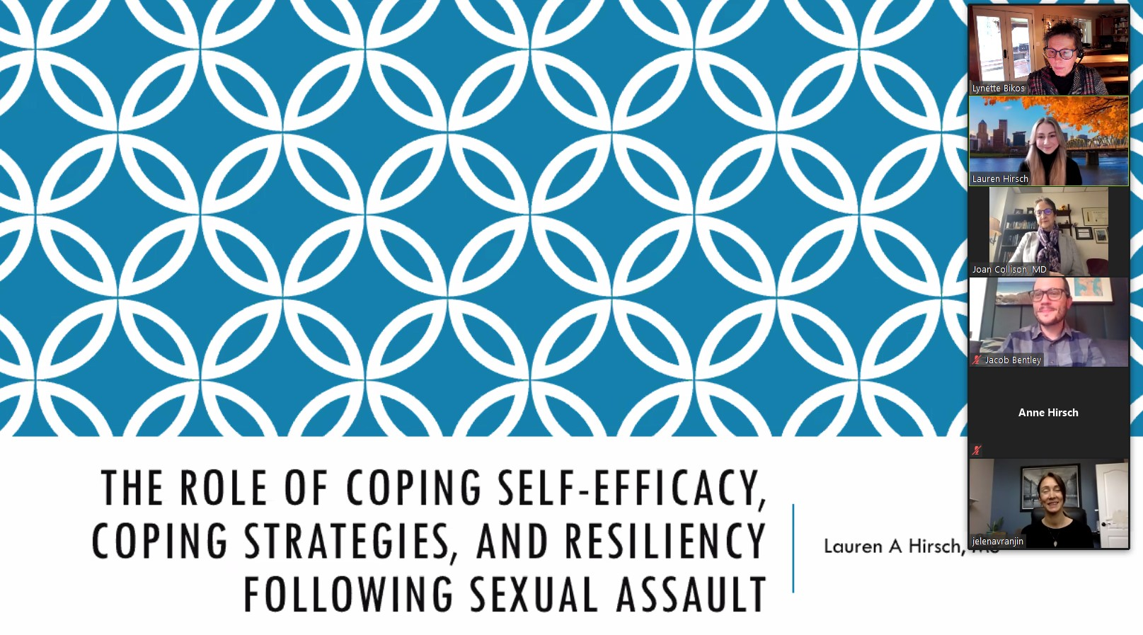

*Image of Lauren’s virtual dissertation defense*.

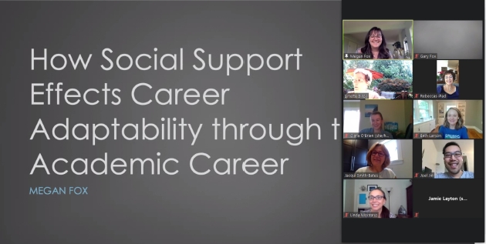

*Image of Megan’s virtual dissertation defense*.

**Megan Fox, PhD**, [*How Social Support Affects Career Adaptability through the Academic Career*](https://digitalcommons.spu.edu/cpy_etd/70/), 2021. Dissertation committee members included Lynette Bikos, PhD (Chair), Joel Jin, PhD, and Jacqui Smith-Bates, EdD.

Dr. Fox’s APA-accredited pre-doctoral internship and post-doctoral appointments were at Eagle Valley Behavioral Health (an outreach of Vail Health), Eagle County, CO. You can find her on [LinkedIn](https://www.linkedin.com/in/megan-fox-9b6190149/)

**Beth Larson, PhD**, [*Attachment, Trait Mindfulness, and Expectations in Married Women: A Moderated Mediation Model*](https://digitalcommons.spu.edu/cpy_etd/69/), 2021. Dissertation committee members included Lynette Bikos, PhD, ABPP (Chair), Joel Jin, PhD, and John Thoburn, PhD, ABPP.

Dr. Larson’s APA-accredited pre-doctoral internship was at the University of Kansas Medical Center, Kansas City, KS. She is completing a General Clinical Psychology (with severe mental health illness emphasis track) Postdoctoral Fellowship at the Kansas City Veterans Administration Medical Center.

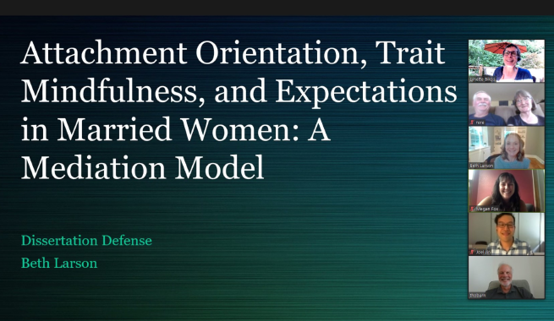

*Image of Beth’s virtual dissertation defense*.

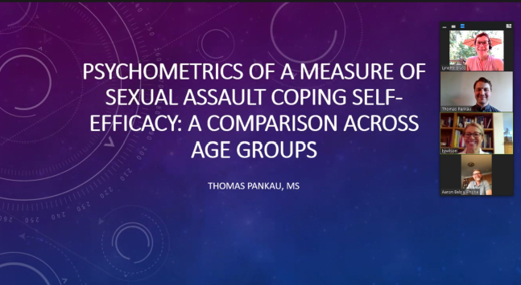

*Image of Thomas’ virtual dissertation defense*.

**Thomas Pankau, PhD**, [*Psychometrics of a Measure of Sexual Assault Coping SElf-Efficacy: A comparison across groups*](https://digitalcommons.spu.edu/cpy_etd/70/), 2021. Dissertation committee members included Lynette Bikos, PhD (Chair), Beverly Wilson, PhD, and Aaron Belz, PhD

Dr. Pankau’s APA-accredited pre-doctoral internship was at Solutions Behavioral Healthcare Professionals in Moorhead, MN. He is completing a postdoctoral fellowship at Kaiser Permanente in San Rafael, CA.

**Caitlin Coyer, PhD**, [*Psychometric Evaluation of the Calling and Vocation Questionnaire-Revised (CVQ-R) and Calling and Vocation Questionnaire-10 Item (CVQ-10)*](https://digitalcommons.spu.edu/cpy_etd/58/), 2020. Dissertation committee members included Lynette Bikos, PhD (Chair), Thane Erickson, PhD, and Jacqui Smith-Bates, EdD.

Dr. Coyer completed an APA-accredited pre-doctoral internship at the Missouri Health Sciences Psychology Consortium in Columbia, MO. She is completing a clinical health psychology postdoctoral fellowship position with the University of Florida. You can find her on [LinkedIn](https://www.linkedin.com/in/caitlin-coyer/)

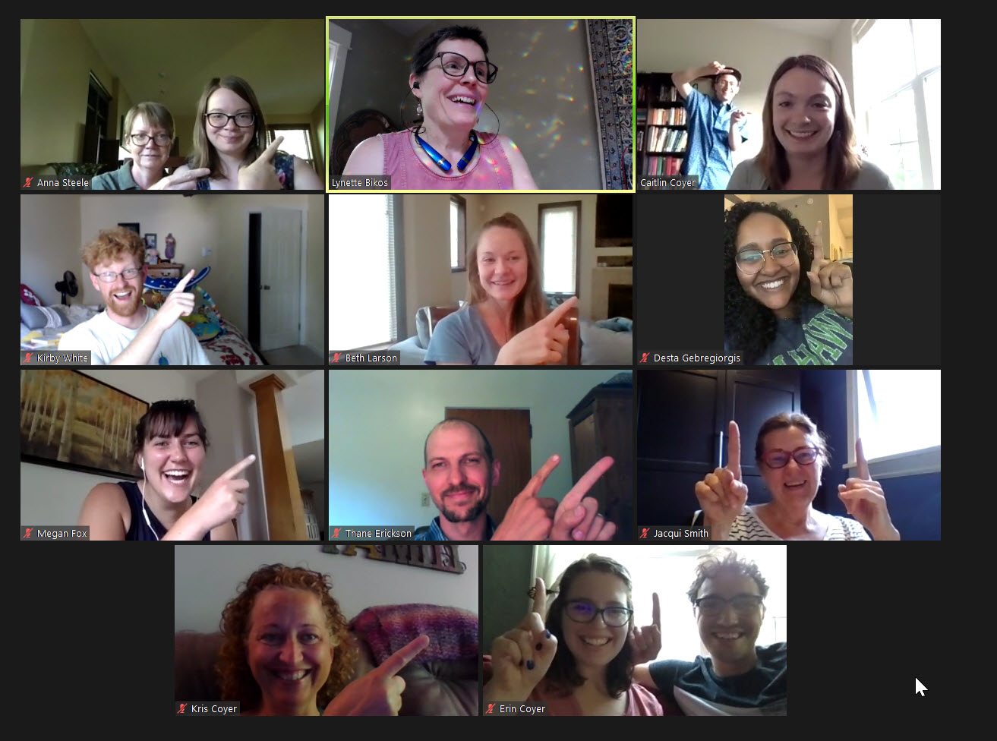

*Image of Caitlin’s virtual dissertation defense*.

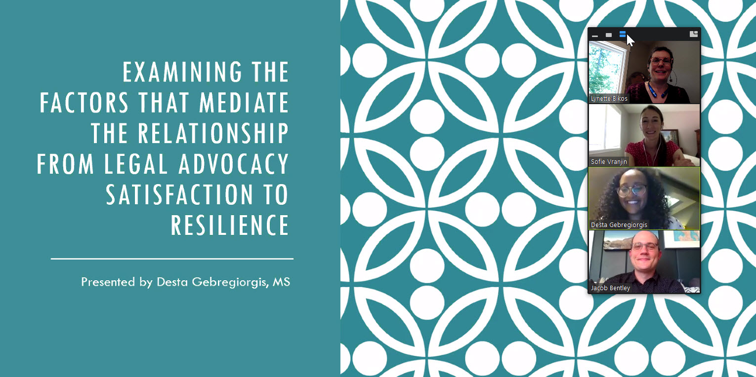

*Image of Desta’s virtual dissertation defense*.

**Desta Gebregiorgis, PhD**, [*Examining the Factors that Mediate the Relationship from Legal Advocacy Satisfaction to Resilience*](https://digitalcommons.spu.edu/cpy_etd/59/), 2020. Dissertation committee members included Lynette Bikos, PhD (Chair), Jacob Bentley, PhD, and Jelena Vranjin, PhD.

Dr. Gebregiorgis completed completed an APA-accredited pre-doctoral internship at the VA Medical Center – Minneapolis, MN. She is currently completing postdoctoral fellowship position in primary care mental health integration at the Seattle VA.

**Melissa Gowen, PhD**, [*Campus Shootings: Does Religious Faith and Relationship with Victims Affect Psychological Well-Being?*](https://digitalcommons.spu.edu/cpy_etd/44/), 2019. Dissertation committee members included Lynette Bikos, PhD (Chair), Amy Mezulis, PhD, and Samantha Slaughter, PsyD.

Dr. Gowen completed an APA-accredited pre-doctoral internship at the Montana VA Health Care System, Fort Harrison, MT.

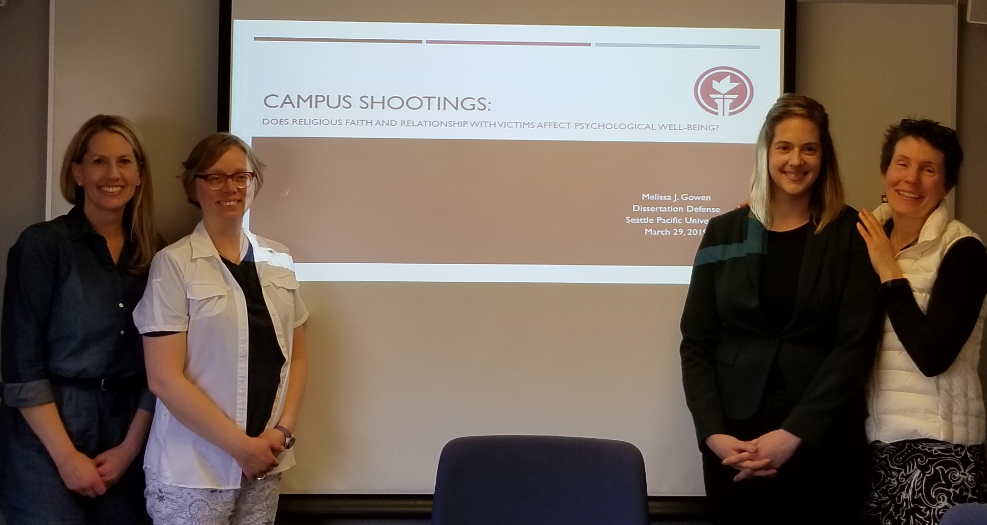

*Image of Melissa’s dissertation defense*.

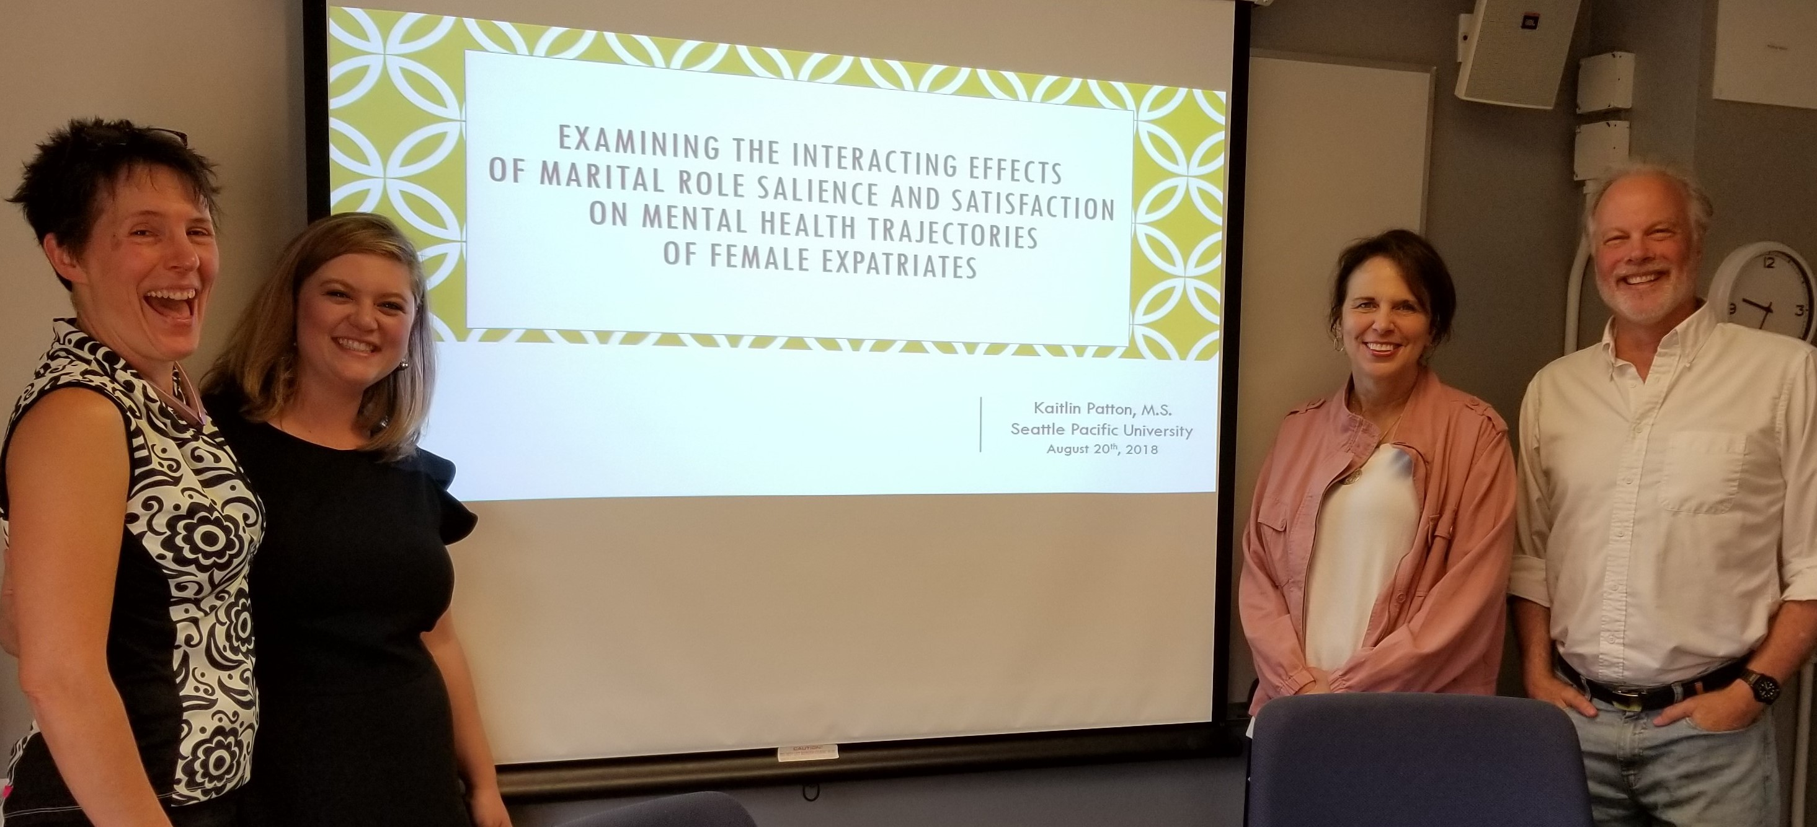

*Image of Kaitlin’s dissertation defense*.

**Kaitlin Patton, PhD** (she/her/hers), [*Examining the interacting effects of marital role salience and satisfaction on first year mental health trajectories of female, expatriate spouses in Turkey*](https://digitalcommons.spu.edu/cpy_etd/39/), 2018. Dissertation committee members included Lynette Bikos, PhD (Chair), John Thoburn, PhD, and Sharleen Kato, PhD.

Dr. Patton completed an APA-accredited pre-doctoral internship at the Southwest Consortium/NMVAHCS, Albuquerque, NM. Subsequently, she completed a postdoctoral fellowship in Psychosocial Rehabilitation and Systems Redesign at the Albuquerque VA. Dr. Patton is currently a clinical psychologist in Newport Beach, CA. You can find her on [LinkedIn](https://www.linkedin.com/in/kaitlinpatton/).

**Clara Roberts, PhD**, [*Sexual Assault Coping Self-efficacy as Moderated by Legal Advocacy Social Support*](https://digitalcommons.spu.edu/cpy_etd/23/), 2017. Dissertation committee members included Lynette Bikos, PhD (Chair), Jacob Bentley, PhD, and Samantha Slaughter, PsyD.

Dr. Roberts completed an APA-accredited pre-doctoral internship at the G.V. (Sonny) Montgomery VA Medical Center, Jackson, MS. Subsequently, Dr. Roberts was a Neuropsychology Postdoctoral Fellow at Neuropsychological Services of New Mexico



*Image of Clara at master’s commencement*.

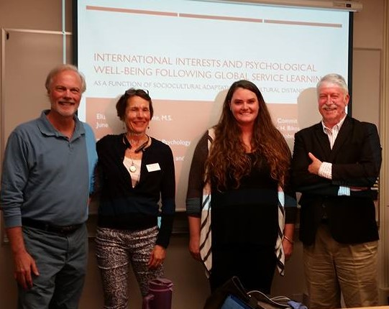

*Image of Liz’s dissertation defense*.

**Elizabeth “Liz” Dykhouse, PhD** (she/her/hers), [*International Interests and Psychological Well-Being Following Global Service Learning as a Function of Sociocultural Adaptation and Cultural Distance*](https://digitalcommons.spu.edu/cpy_etd/16/), 2016. Dissertation committee members included Lynette Bikos, PhD (Chair), John Thoburn, PhD, and Ross Stewart, PhD. The dissertation was subsequently published in the *International Journal of Intercultural Relations* (Dykhouse & Bikos, 2019)

Dr. Dykhouse completed an APA-accredited pre-doctoral internship at I Ola Lahui Rural Hawaii Behavioral, Honolulu, HI. Subsequently Dr. Dykhouse completed a postdoctoral fellowship in Primary Care Psychology at Salud Family Health Centers, Denver, CO. She is presently an Assistant Professor in Family Medicine and Community Health at the University of Massachusetts Medical School. You can find her on [LinkedIn](https://www.linkedin.com/in/liz-dykhouse-a7727371/).

**Minhdan “Danee” Thuey Ta, PhD** (she/her/hers), [*Psychometric Evaluation of the Offender Coping Self-Efficacy Scale in the Context of Incarceration and Upon Re-Entry*](https://digitalcommons.spu.edu/cpy_etd/12/), 2016. Dissertation committee members included Lynette Bikos, PhD (Chair), David G. Stewart, PhD, and Arthur G. Davis, PhD.

Dr. Ta completed an APA-accredited pre-doctoral internship at Patton State Hospital, Patton, California. Subsequently, Dr. Ta completed a postdoctoral fellowship in Forensic Psychology at Patton State Hospital. Dr. Ta is currently a licensed psychologist with the Orange County Conditional Release Program.

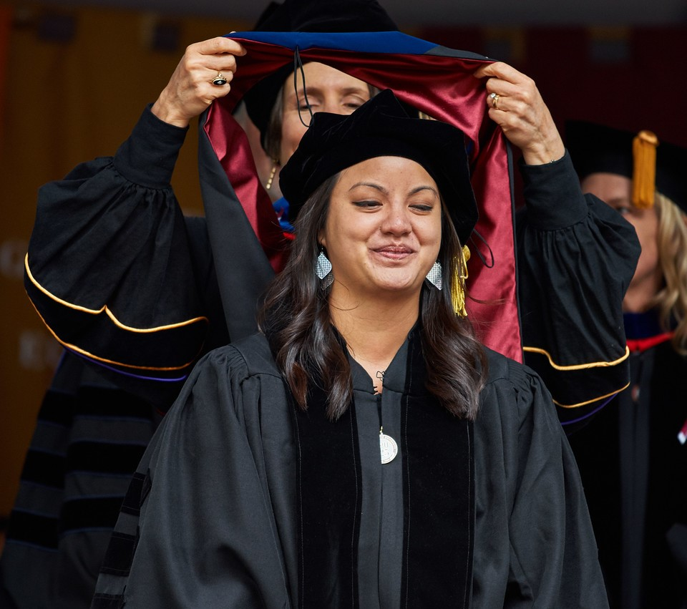

*Image of Danee’s dissertation defense*.

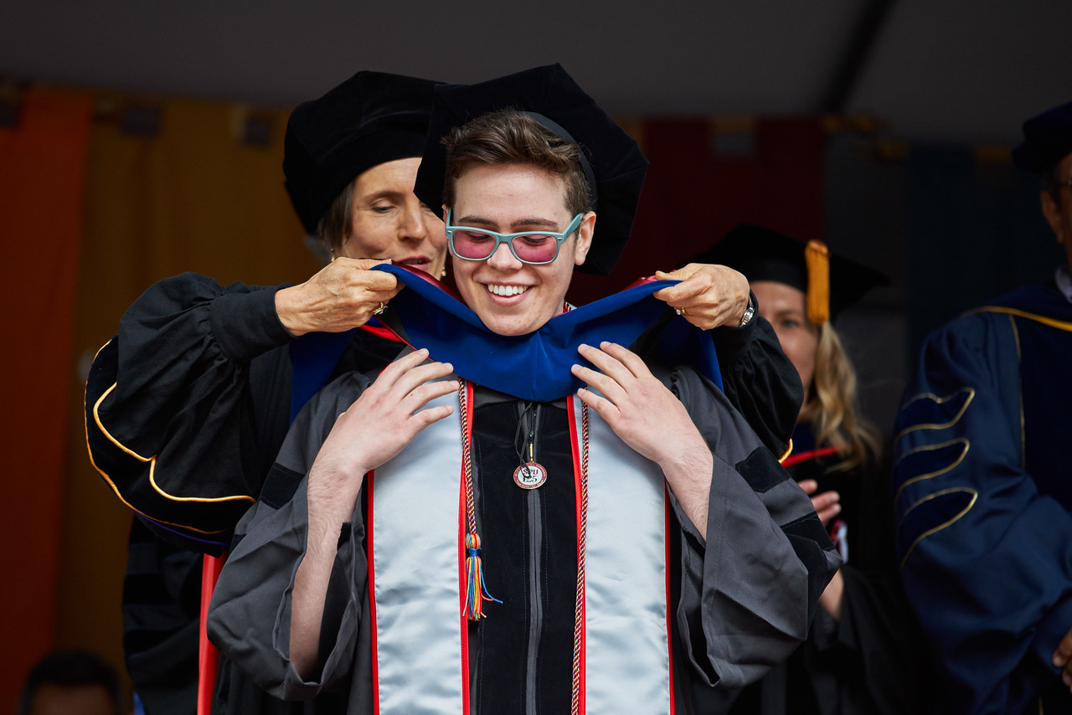

*Image of Sage at doctoral hooding*.

**Sage Liam Willis, PhD**, [*Queers in the Hands of a Loving God: God Image, Strength of Faith, and Campus Climate in Predicting Self-Stigma, 2016*](https://digitalcommons.spu.edu/cpy_etd/13/). Dissertation committee members included Lynette Bikos, PhD (Chair), Marcia Webb, PhD, David Stewart, PhD, and Jenny Arm, PsyD.

Dr. Willis completed an APA-accredited pre-doctoral internship at Washington State University Counseling, Pullman, WA.

**Mari Yamamoto, PhD** (she/her/hers), [*Behavioral Health among Asian American and Pacific Islanders: The Impact of Acculturation and Receipt of Behavioral Health Services on Depression and Anxiety*](https://digitalcommons.spu.edu/cpy_etd/8/), 2015. Dissertation committee members included Lynette Bikos, PhD (Chair), John Thoburn, PhD, and Jacob A. Eide, PsyD.

Dr. Yamamoto completed an APA-accredited pre-doctoral internship at VA Northern California Health Care System, Martinez, CA. Subsequently, she held a postdoctoral fellowship in primary care mental health integration at VA Puget Sound Health Care System. Dr. Yamamoto keeps an updated profile at [LinkedIn](https://www.linkedin.com/in/mari-yamamoto-802a2a4/).

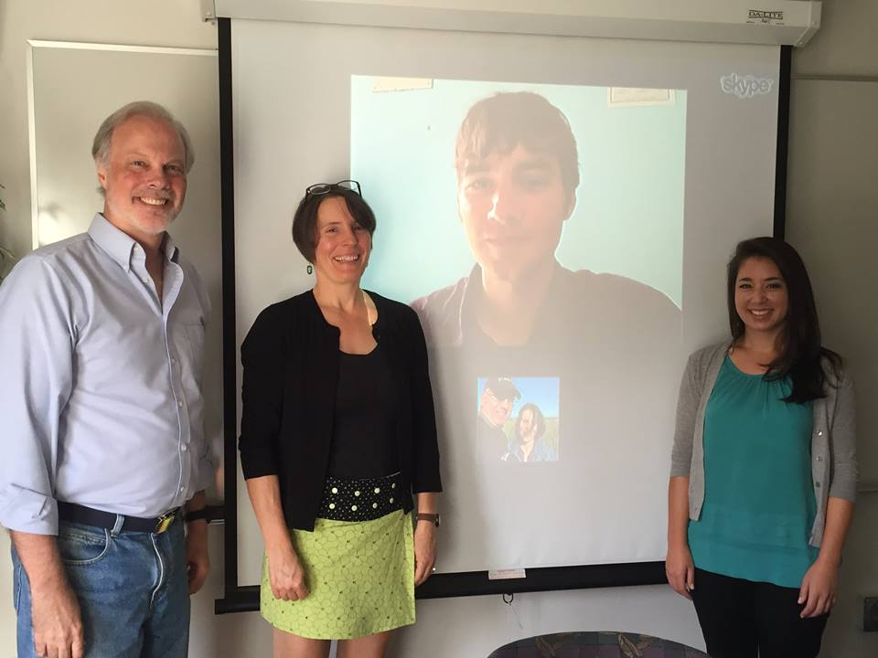

*Image of Mari’s dissertation defense*.

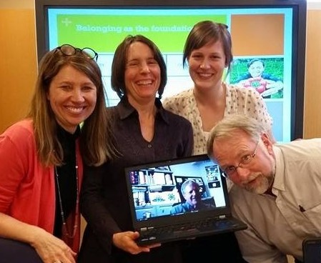

*Image of Megan at doctoral hooding*.

**Megan (Zurawski) Goldenshteyn, PhD** (she/her/hers), [*Perspectives on a Positive Youth Development Environment for Youth with Developmental Disabilities in 4-H*](https://digitalcommons.spu.edu/cpy_etd/2/), 2015. Dissertation committee members included Lynette Bikos, PhD (Chair), Beverly J. Wilson, PhD, Christopher A. Sink, PhD, and Kirk Astroth, Ed.D.

Dr. Goldenshteyn completed an APA-accredited pre-doctoral internship Morrison Child & Family Services, Gresham, OR. Subsequently, she was a Postdoctoral Fellow through the University of Washington’s LEND program and Clinical Training Unit at the Center on Human Development and Disability

**Kim H. Huynh, PhD**, *Establishing Efficacy of the Positive Reentry in Corrections Program: A Consensual Qualitative Research Evaluation of a Positive Psychology Intervention for Prison Inmates*, 2014. Dissertation committee members included Lynette Bikos, PhD (Chair), David G. Stewart, PhD, and Mark Hurst, PhD. A variant of the dissertation was published in the *International Journal of Offender Therapy and Comparative Criminology* (Huynh et al., 2015),

Dr. Huynh completed an APA-accredited pre-doctoral internship at VA Northern California Health Care System, Martinez, CA. Subsequently, Dr. Huynh was a Postdoctoral Fellow at San Francisco VA Medical Center, PTSD Clinical Team.

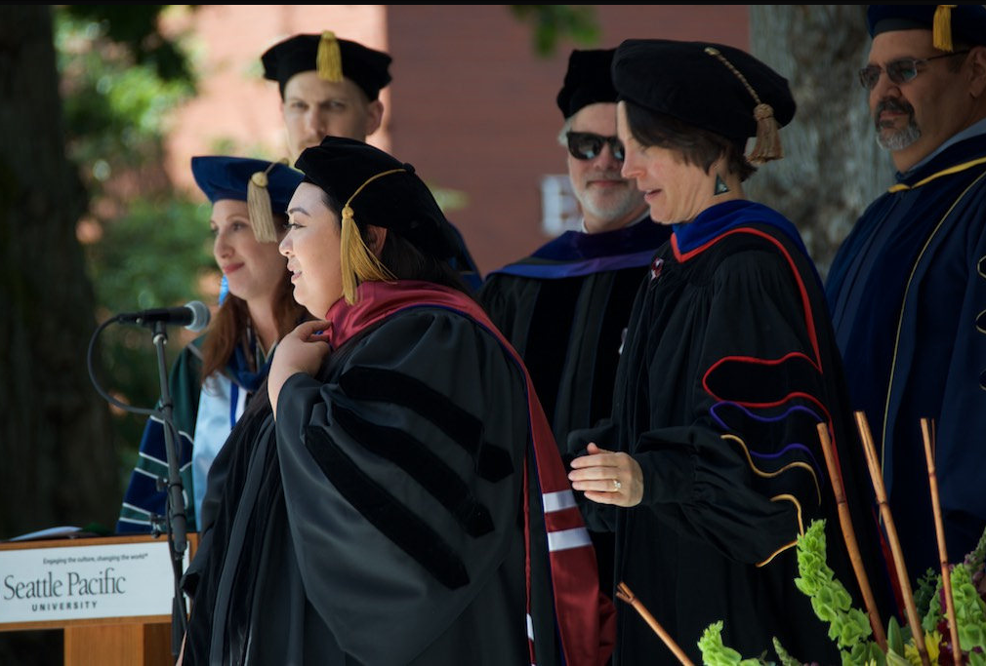

*Image of Kim’s doctoral hooding*.

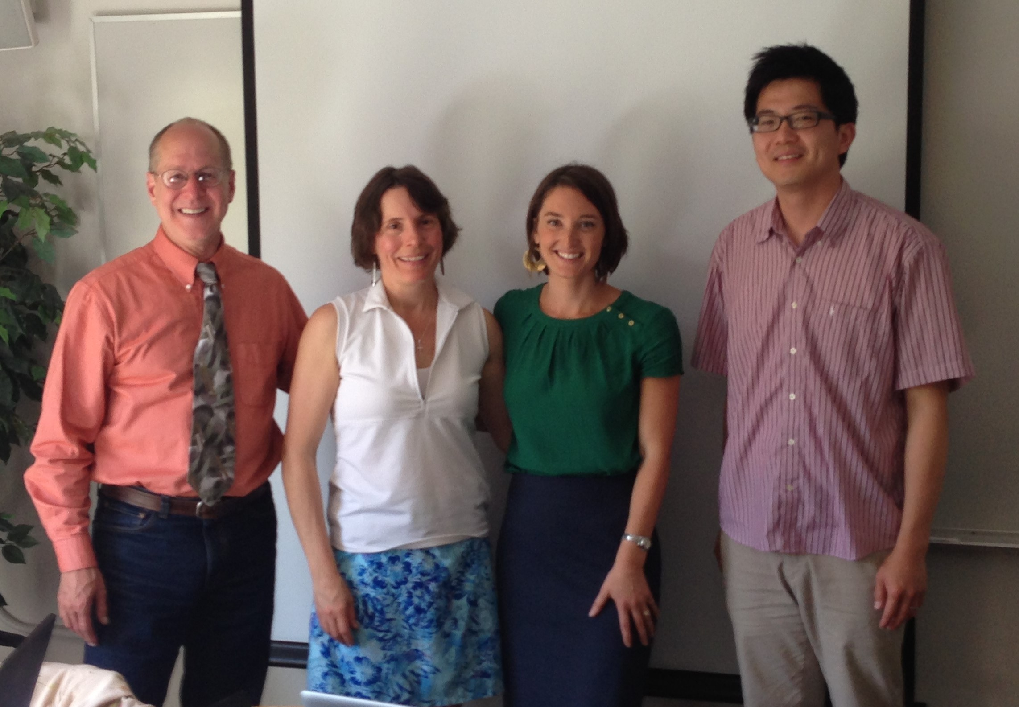

*Image of Nicola’s dissertation defense*.

**Nicola F. Chism De Paul, PhD**, *Modeling Effectiveness Outcomes Among Expatriate Professionals Working for Non-Governmental Organizations*, 2013. Dissertation committee members included Lynette Bikos, PhD (Chair), Jay Skidmore, PhD, and Paul Youngbin Kim, PhD. A portion of the dissertation data was published in the *International Journal of International Relations* (De Paul & Bikos, 2015).

Dr. Chism completed an APA-accredited predoctoral internship at Southwest Consortium VA Healthcare, Albuquerque, NM. Subsequently, Dr. Chism was a Post-Doctoral Fellow at VA Puget Sound Health Care System.

**Rebekah Forman, PhD**, *Development and Validation of the Sociocultural Adaptation Self-Efficacy Evaluation*, 2013. Dissertation committee members included Lynette Bikos, PhD (Chair), John Thoburn, PhD, and Paul Youngbin Kim, PhD. Dissertation data and analyses contributed to a larger study published in *The Counseling Psychologist* (Bikos et al., 2021).

Dr. Forman completed an APA-accredited pre-doctoral internship at McGuire VA Medical Center, Richmond, Virginia. Subsequently, Dr. Forman was a Postdoctoral Fellow at Neuropsychology and Complementary Medicine.

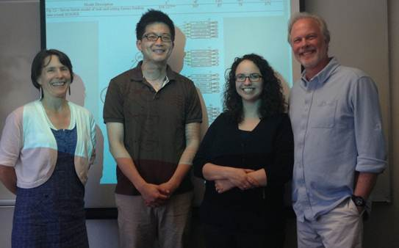

*Image of Rebekah’s dissertation defense*.

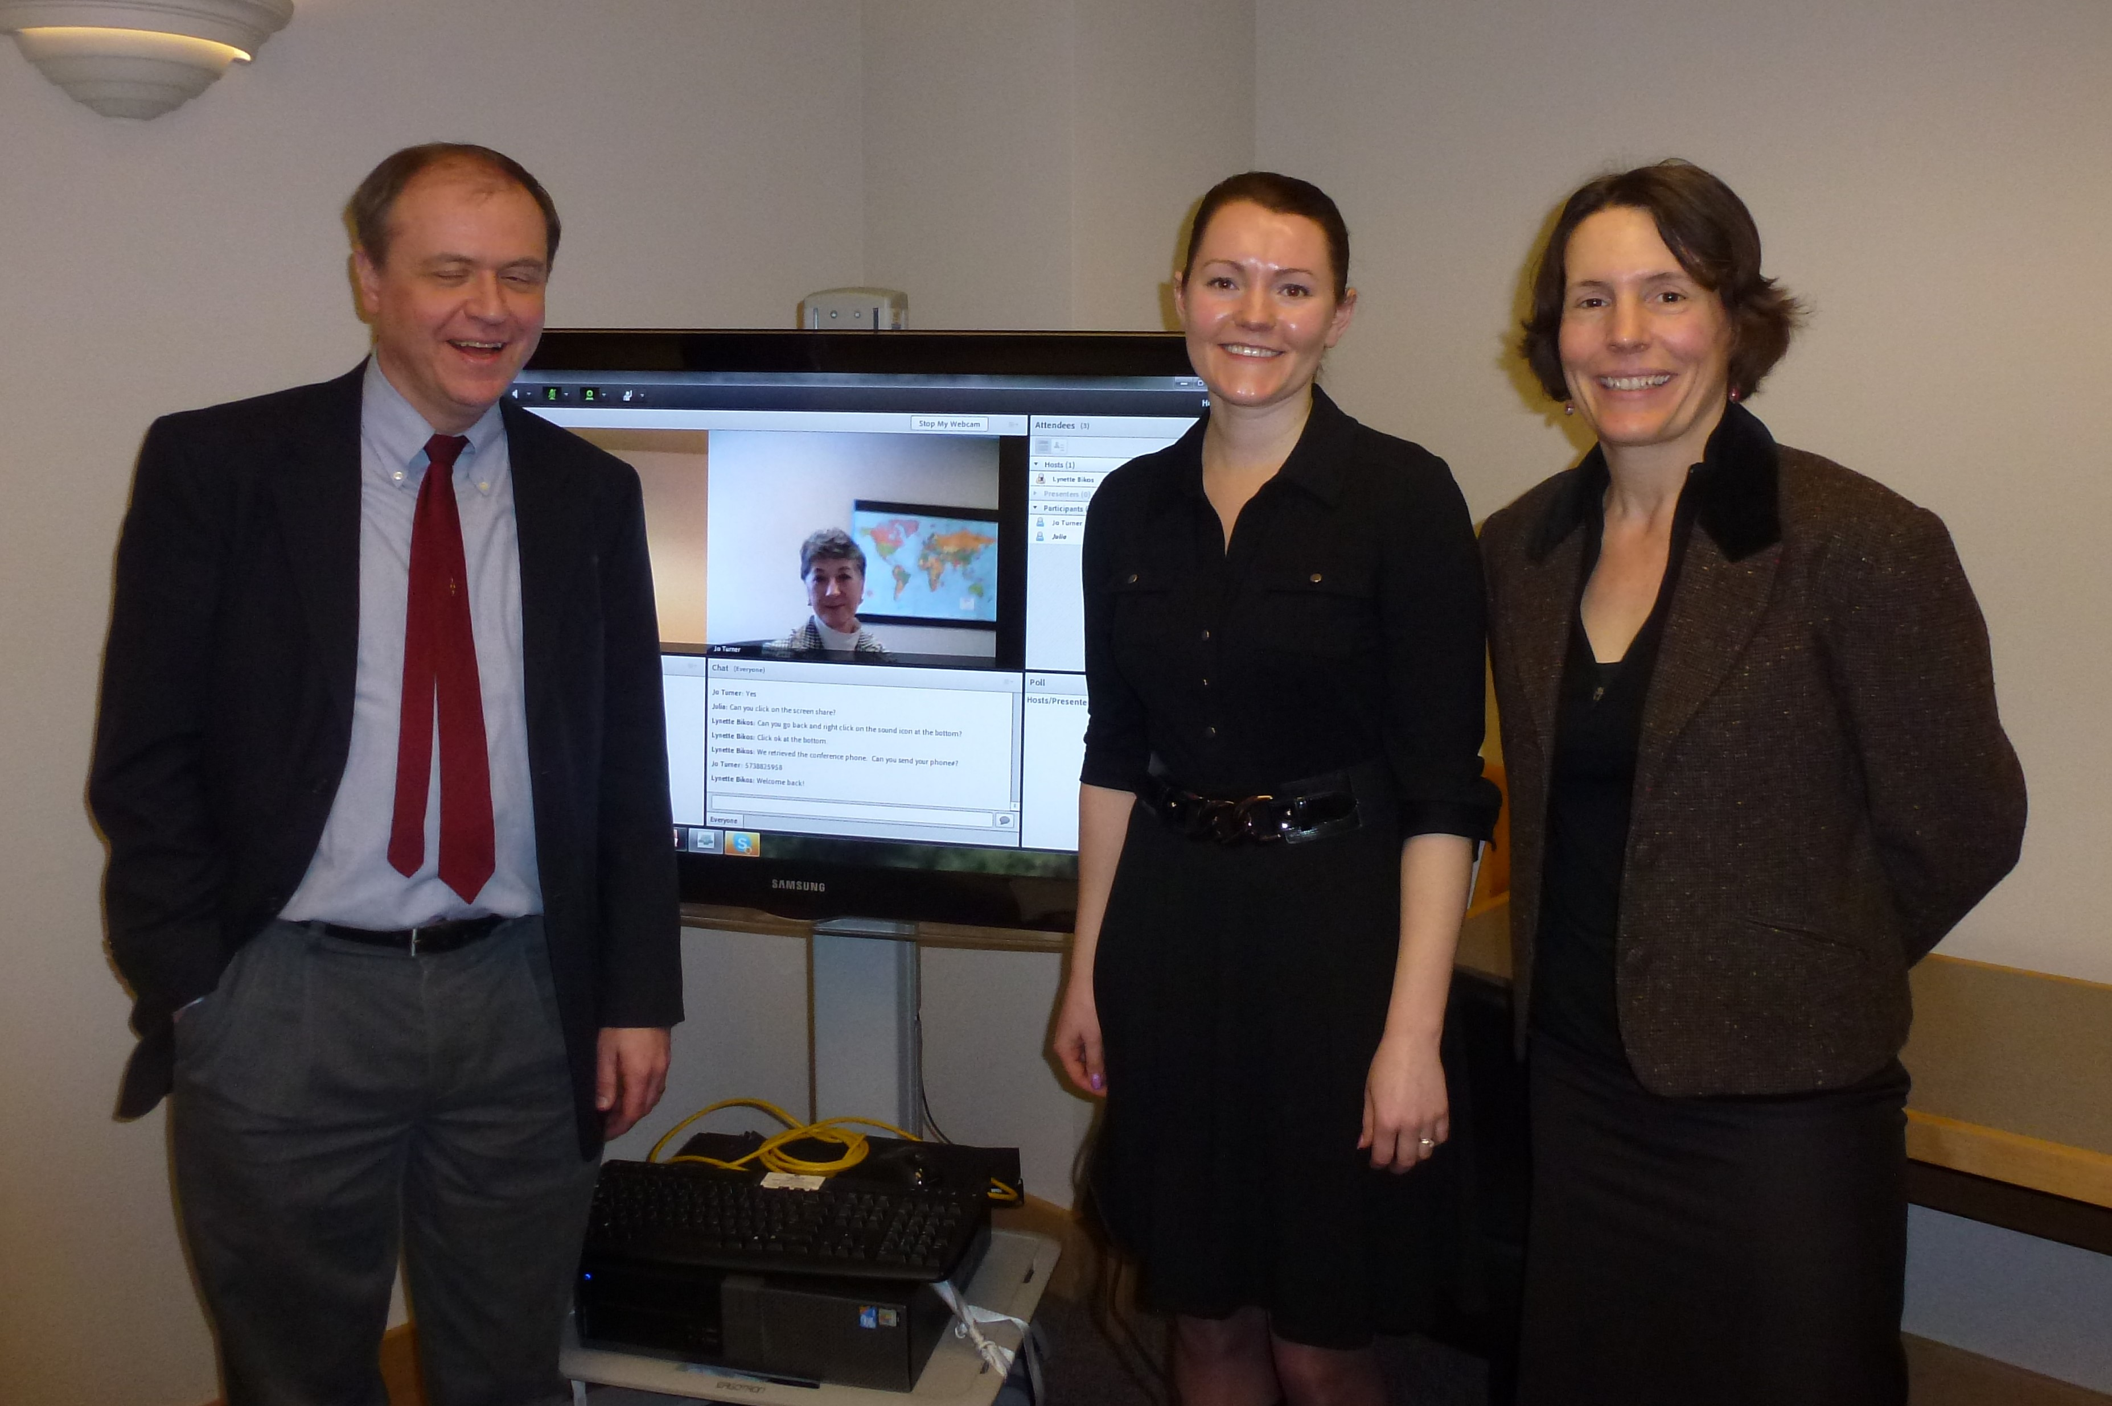

*Image of Julia’s dissertation defense*.

**Julia Kocheleva Bergman Tillmann, PhD** (she/her/hers), *Development and Validation of the 4-H Research Utilization Self-Efficacy Scale*, 2013. Dissertation committee members included Lynette Bikos, PhD (Chair), Paul Yost, PhD, and Jo Turner, PhD. A variant of the dissertation was published in the *Journal of Youth Development: Research & Practice* (Tillmann & Bikos, 2014).

Dr. Tillmann has held a number of consulting and research-related roles, including Director of Research, at Limeade Institute, Bellevue, WA. Dr. Tillmann keeps an updated profile at [LinkedIn](https://www.linkedin.com/in/juliannetillmann/).

**Jelena Agatonovic Vranjin, PhD**, *Establishing Efficacy of the TAKE-5 Program: An Intervention for Nonoffending Foster Parents of Sexually Abused Children*, 2012. Dissertation committee members included Lynette Bikos, PhD (Chair), John Thoburn, PhD, and David G. Stewart, PhD.

Dr. Vranjin completd an APA-accredited pre-doctoral internship at Central Washington University. Dr. Vranjin is a psychologist at Eastside Psychological Associates, Woodinville, WA.

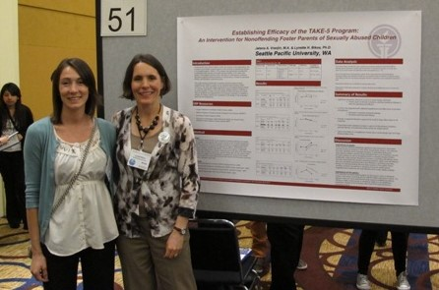

*Image of Jelena showing dissertation poster at the Western Psychological Association*.

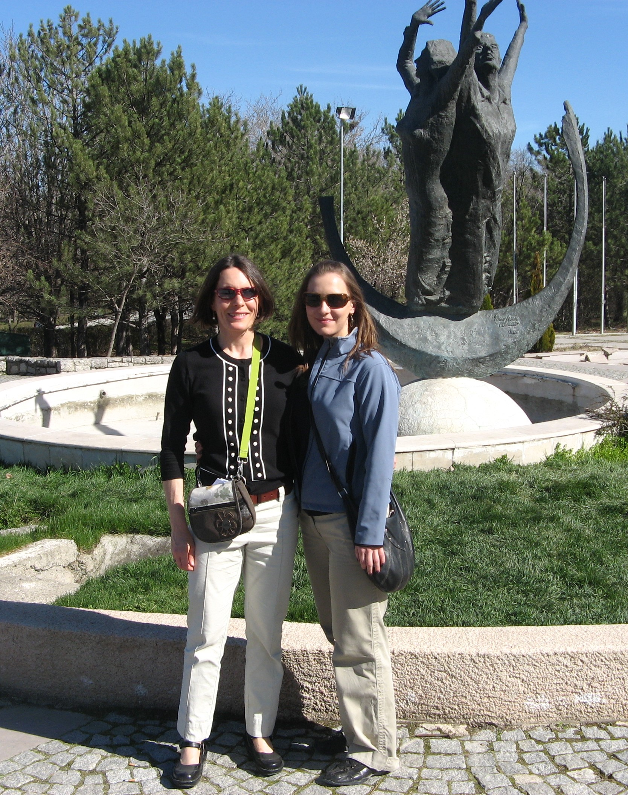

*Image of Renee Gibbs and Lynette Bikos in Turkey where Renee was collecting dissertation data*.

**Renee Gibbs, PhD**, *Psychological Adjustment and Sociocultural Adaptation of International Students in Turkey*, 2011. Dissertation committee members included Lynette Bikos, PhD (Chair), John Thoburn, PhD, Jeff Jordan, EdD, and Oya Yerin-Guneri, PhD. The dissertation was subsequently published in the Psychology of Sustainability Section of the journal, *Sustainability* (Gibbs et al., 2020).

Dr. Gibbs completed an APA-accredited pre-doctoral internship at Dutchess County Department of Mental Health, New York. Subsequently, Dr. Gibbs was a Post-doctoral Fellow at the Central Arkansas VA Medical Center.

### Not pictured (we weren’t carrying cell phones with cameras)

* **Leigh Anne Randa, PhD**, *An Exploration of Emotional Sobriety: The Experience of Shame and Guilt for the Alcoholic Working the Twelve Step Recovery Program of Alcoholics Anonymous*, 2010.
  + APA-accredited pre-doctoral internship at VA Medical Center, Iowa City, IA.
  + Post-doctoral fellowship at VA Hospital, Columbia, MO.
* **Michael J. Klemens, PhD** (2008). *Psychological Well-Being, Ethnic Identity, and Sociocultural Adaptation in College Aged Missionary Kids*, 2008.
  + The dissertation was subsequently published in *Mental Health, Religion, & Culture* (Klemens & Bikos, 2009).

### References

Bikos, L. H., Forman, R., & Patton, K. M. (2021). The Self-Efficacy for Sociocultural Adaptation Scale (SESCAS): Development and Initial Psychometric Evaluation. *The Counseling Psychologist*, *49*(1), 33–79. <https://doi.org/10.1177/0011000020951861>

De Paul, N. F., & Bikos, L. H. (2015). Perceived organizational support: A meaningful contributor to expatriate development professionals’ psychological well-being. *International Journal of Intercultural Relations*, *49*, 25–32. <https://doi.org/10.1016/j.ijintrel.2015.06.004>

Dykhouse, E. C., & Bikos, L. H. (2019). Re-entry friction: The curious effects of cultural dislocation on outcomes for global service learning returnees. *International Journal of Intercultural Relations*, *72*, 96–108. <https://doi.org/10.1016/j.ijintrel.2019.07.004>

Gibbs, R., Guneri, O. Y., Pankau, T., & Bikos, L. H. (2020). Birds of a Feather Fare Less Well Together: Modeling Predictors of International Student Adaptation. *Sustainability*, *12*(6), 2317. <https://doi.org/10.3390/su12062317>

Huynh, K. H., Hall, B., Hurst, M. A., & Bikos, L. H. (2015). Evaluation of the positive re-entry in corrections program: A positive psychology intervention with prison inmates. *International Journal of Offender Therapy and Comparative Criminology*, *59*(9), 1006–1023. <https://doi.org/10.1177/0306624X14523385>

Klemens, M. J., & Bikos, L. H. (2009). Psychological well-being and sociocultural adaptation in college-aged, repatriated, missionary kids. *Mental Health, Religion & Culture*, *12*(7), 721–733. <https://doi.org/10.1080/13674670903032629>

Tillmann, J., & Bikos, L. H. (2014). Explaining Research Utilization Among 4-H Faculty, Staff, and Volunteers: The Role of Self-Efficacy, Learning Goal Orientation, Training, and Previous Experience. *Journal of Youth Development*, *9*(2), 133–148. <https://doi.org/10.5195/jyd.2014.65>